**BLESSING**

L) May you be filled with the wonder of Mary, the obedience of Joseph, the joy of the angels, the eagerness of the shepherds, the determination of the magi, and the peace of the Christ Child. Almighty God, Father, (+) Son, and Holy Spirit bless you now and forever.

**All) Amen.**

*The candles are extinguished.*

**READING Luke 2:8-20 Bible Pg. 833**

8In that region there were shepherds living in the fields, keeping watch over their flock by night. 9Then an angel of the Lord stood before them, and the glory of the Lord shone around them, and they were terrified. 10But, the angel said to them, “Do not be afraid; for see – I am bringing you good news of great joy for all the people: 11to you is born this day in the city of David a Savior, who is the Messiah, a the Lord. 12This will be a sign for you: you will find a child wrapped in bands of cloth and lying in a manger. 13And suddenly there was with the angel a multitude of the heavenly host, b praising God and saying, 14”Glory to God in the highest heaven, and on earth peace among those whom he favors!”c

15When the angels had left them and gone into heaven, the shepherds said to one another, “Let us go now to Bethlehem and see this thing that has taken place, which the Lord has made known to us.” 16So they went with haste and found Mary and Joseph, and the child lying in the manger. 17When they saw this, they made known what had been told them about this child; 18and all who heard it were amazed at what the shepherds told them. 19But Mary treasured all these words and pondered them in her heart. 20The shepherds returned, glorifying and praising God for all they had heard and seen, as it had been told them.

**SENDING SONG: “*Joy to the World!”*** **ELW #267**

**DISMISSAL**

L) Christ the Savior is born! Proclaim this good news and go in peace.

**All) Thanks be to God.**

**POSTLUDE**

*“But when the kindness and love of God our Savior appeared, he saved us—not because of righteous things we had done—but because of his mercy.”*

*~ Titus 3:4-5*

**Colton Lutheran Parish**

December 25th, 2024

**St. Jacobs:** Christmas Day CandlelightWorship Service 9 a.m.

**Colton Lutheran Parish website:** [**www.coltonlutheran.com**](http://www.coltonlutheran.com)

Pastor Herb Wounded Head, III Secretary: Kim Kagarise

Pastor’s Email: [herbwh@gmail.com](mailto:herbwh@gmail.com) Office Email: [coltonlutheranparish@gmail.com](mailto:coltonlutheranparish@gmail.com)

#### Church office phone number: (605) 446-3271

***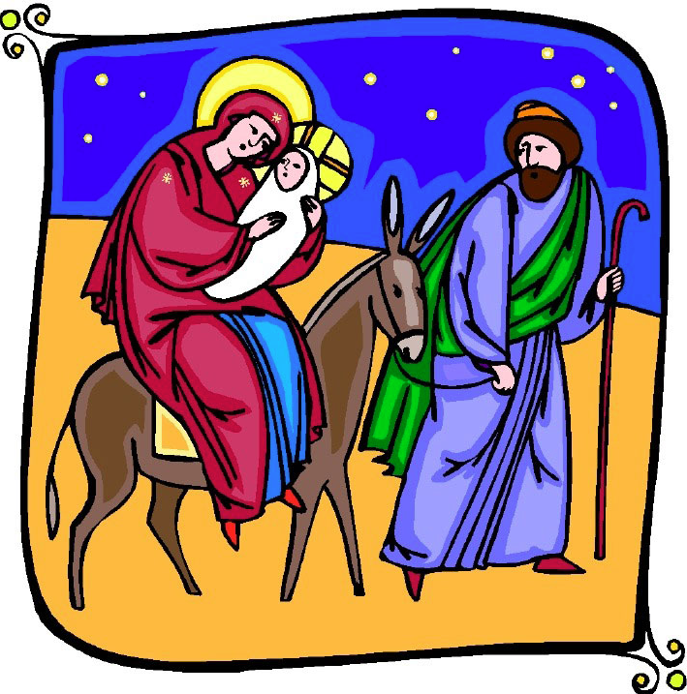****Portions of this service reprinted using CCLI Copyright License #11610749*

***The Nativity of Our Lord***

***NOTE:*** *If it is uncomfortable for you to stand during the service, please feel free to remain seated.*

**MUSIC PRELUDE**

**WELCOME and ANNOUNCEMENTS**

**PROCLAMATION OF THE BIRTH OF CHRIST**

**GATHERING HYMN *“O Come, All Ye Faithful”*** *(vv. 1-3)* **ELW #283**

**CHRISTMAS DIALOG AND GREETING**

L) The people who walked in darkness have seen a great light.

**All) The light shines in the darkness, and the darkness has not overcome it.**

L) Those who dwelt in the land of deep darkness, on them light has shined.

**All) We have beheld Christ’s glory, glory as of the only Son from the Father.**

L) For to us a child is born, to us a Son is given.

**All) In him was life, and the life was the light of all people.**

L) May the grace and truth of Christ be with you.

**All) And also with you.**

**PRAYER OF THE DAY**

L) Let us pray together,

**All) Almighty God, You made this holy night shine with the brightness of the true Light.**

**Grant that here on earth we may walk in the light of Jesus’ presence and in the last**

**day wake to the brightness of his glory; through Your Son, Jesus Christ our Lord,**

**who lives and reigns with You and the Holy Spirit, one God, now and forever. Amen.**

**HYMN: *“O Little Town of Bethlehem”*** *(vv. 1-3)* **ELW *#279***

**FIRST READING: Isaiah 9:2-7 Bible Pg. 555**

2The people who walked in darkness have seen a great light; those who lived in a land of deep darkness— on them light has shined. 3You have multiplied the nation, you have increased its joy; they rejoice before you as with joy at the harvest, as people exult when dividing plunder. 4For the yoke of their burden, and the bar across their shoulders, the rod of their oppressor, you have broken as on the day of Midian. 5For all the boots of the tramping warriors and all the garments rolled in blood shall be burned as fuel for the fire. 6For a child has been born for us, a son given to us; authority rests upon his shoulders; and he is named Wonderful Counselor, Mighty God, Everlasting Father, Prince of Peace. 7His authority shall grow continually, and there shall be endless peace for the throne of David and his kingdom. He will establish and uphold it with justice and with righteousness from this time onward and forevermore. The zeal of the Lord of hosts will do this.

L) The Word of the Lord.

**All) Thanks be to God.**

**HYMN: *“Hark! The Herald Angels Sing”* ELW #270**

**PSALM LITANY PSALM 96 Bible Pgs. 479-480**

L) O sing to the LORD a new song; sing to the LORD, all the earth.

**All) Sing to the LORD, bless his name; tell of his salvation from day to day.**

L) Declare his glory among the nations, his marvelous works among all the peoples.

**All) For great is the LORD, and greatly to be praised; he is to be revered above all**

L) For all the gods of the peoples are idols, but the LORD made the heavens.

**All) Honor and majesty are before him; strength and beauty are in his sanctuary.**

L) Ascribe to the LORD, O families of the peoples, ascribe to the LORD glory and strength.

**All) Ascribe to the LORD the glory due to his name; bring an offering, and come into**

**his courts.**

L) Worship the LORD in holy splendor; tremble before him, all the earth.

**All) Say among the nations, “The LORD is king! The world is firmly established; it**

**shall never be moved. He will judge the peoples with equity.”**

L) Let the heavens be glad, and let the earth rejoice; let the sea roar, and all that fills it;

**All) let the field exult, and everything in it. Then shall all the trees of the rest sing for joy**

L) before the LORD; for he is coming, for he is coming to judge the earth. He will judge the world with righteousness, and the peoples with his truth.

**SECOND READING: Titus 2:11-14 Bible Pg. 969**

11For the grace of God has appeared, bringing salvation to all, 12training us to renounce impiety and worldly passions, and in the present age to live lives that are self-controlled, upright, and godly, 13while we wait for the blessed hope and the manifestation of the glory of our great God and Savior, Jesus Christ. 14He it is who gave himself for us that he might redeem us from all iniquity and purify for himself a people of his own who are zealous for good deeds.

L) The Word of the Lord.

**All) Thanks be to God.**

**HYMN *“Away in a Manger”* ELW #277**

**THE CHRISTMAS GOSPEL: Luke 2:1-7 Bible Pgs. 832-833**

L) The Holy Gospel according to Luke, the 2nd chapter.

**All) Glory to you, O Lord.**

2In those days a decree went out from Emperor Augustus that all the world should be registered. 2This was the first registration and was taken while Quirinius was governor of Syria. 3All went to their own towns to be registered. 4Joseph also went from the town of Nazareth in Galilee to Judea, to the city of David called Bethlehem, because he was descended from the house and family of David. 5He went to be registered with Mary, to whom he was engaged and who was expecting a child. 6While they were there, the time came for her to deliver her child. 7And she gave birth to her firstborn son and wrapped him in bands of cloth, and laid him in a manger, because there was no place for them in the inn.

L) The Gospel of the Lord

**All) Praise to you, O Christ.**

**SERMON Pastor Herb Wounded Head III**

**HYMN OF THE DAY: *“It Came Upon the Midnight Clear”*****ELW #282**

**PRAYERS OF INTERCESSION “*Watch, O Lord”* Poinsettia insert**

**OFFERING:**

**OFFERTORY HYMN: “*I Am So Glad*”** *(vv. 1, 4-5)* **ELW #271**

**SACRAMENT OF HOLY COMMUNION**

**WORDS OF INSTITUTION**

**LORD’S PRAYER Pg. 154**

L) Lord, remember us in your kingdom and teach us to pray;

**All) Our Father, who art in heaven,**

**Hallowed by thy name,**

**Thy kingdom come, thy will be done,**

**On earth as it is in heaven.**

**Give us this day our daily bread,**

**and forgive us our trespasses,**

**as we forgive those who trespass against us;**

**and lead us not into temptation,**

**but deliver us from evil.**

**For thine is the kingdom,**

**and the power and the glory,**

**Forever and ever. AMEN.**

**DISTRIBUTION**

*Holy Communion will be* *served continuously around the Communion rail. God does not turn us*

*away from our need for grace, nor does He turn us away from the love and mercy freely given*

*in this simple shared meal of Jesus’ own self. All people are welcome to share in this holy*

*meal.*

**THE GOSPEL of the INCARNATION John 1:1-14 Bible Pg. 862**

1In the beginning was the Word, and the Word was with God, and the Word was God. 2He was in the beginning with God. 3All things came into being through him, and all without him not one thing came into being. What has come into being 4in him was life, aand the life was the light of all people. 5The light shines in the darkness, and the darkness did not overcome it.

6There was a man sent from God, whose name was John. 7He came as a witness to testify to the light, so that all might believe through him. 8He himself was not the light, but he came to testify to the light. 9The true light, which enlightens everyone, was coming into the world.b

10He was in the world, and the world came into being through him; yet the world did not know him. 11He came to what was his own, cand his own people did not accept him. 12But to all who received him, who believed in his name, he gave power to become children of God, 13who were born, not of blood or of the will of the flesh or of the will of man, but of God.

L) The Gospel of the Lord

**All) Praise to you, O Christ.**

**Lighting of Candles**

*The minister lights a large candle from an altar candle, which symbolizes Christ, the Light of the world of whom John’s gospel speaks. The ushers light their candles from the minister’s candle, then light the candle of each worshipper nearest the aisle. The lighted candle is never tilted, but is always held upright when giving light to another. After all of the candles are lit, the ushers turn down the lights for the prayers.*

**THE PRAYERS**

L) Glory to God in the highest,

**All) and peace to God’s people on earth.**

L) Blessed are you, Prince of Peace. You rule the earth with truth and justice.

**All) Send your gift of peace to all nations of the world.**

L) Blessed are you, Wonderful Counselor. You enlighten the heart with steadfast love.

**All) Enliven your church that it might bear good tidings of great joy to all people.**

L) Blessed are you, Emmanuel. You promise to be with us even to the end of the age.

**All) Open our eyes to see your presence in all who are hungry, lonely, or homeless.**

L) Blessed are you, Son of Mary. You share our humanity.

**All) Have mercy on the sick, the dying, and all who suffer this day.**

L) Blessed are you, Son of God. You dwell among us as the Word made flesh.

**All) Reveal yourself to us in word and sacrament that we may bear your light to all the**

**world.**

**HYMN: “*Silent Night! Holy Night!*** *(v. 3 acapella)* **ELW #281**

**PRAYER**

L) Let us pray.

Holy God, heaven and earth come together this holy night as we remember and celebrate the birth of your Son. In the infant Jesus you come close to us, that we might be close to you, and close to one another. Grant that the Spirit of Christ may be born anew in our hearts tonight and that we may joyfully welcome him to take charge of our lives. Open our ears to hear the angelic Gospel. Open our lips that we may join the angelic chorus, singing with uplifted hearts: “Glory to God in the highest, and on earth, peace goodwill to all.” We pray in Jesus’ name.

**All) Amen.**