BLESSING
L) May you be filled with the wonder of Mary, the obedience of Joseph, the joy of the angels, the eagerness of the shepherds, the determination of the magi, and the peace of the Christ Child. Almighty God, Father, (+) Son, and Holy Spirit bless you now and forever.
All) Amen.

The candles are extinguished.

READING Luke 2:8-20 Bible Pg. 833
⁸In that region there were shepherds living in the fields, keeping watch over their flock by night. ⁹Then an angel of the Lord stood before them, and the glory of the Lord shone around them, and they were terrified. ¹⁰But, the angel said to them, “Do not be afraid; for see – I am bringing you good news of great joy for all the people: ¹¹to you is born this day in the city of David a Savior, who is the Messiah, ª the Lord. ¹²This will be a sign for you: you will find a child wrapped in bands of cloth and lying in a manger. ¹³And suddenly there was with the angel a multitude of the heavenly host, ^{b} praising God and saying, ¹⁴”Glory to God in the highest heaven, and on earth peace among those whom he favors!”^{c}
¹⁵When the angels had left them and gone into heaven, the shepherds said to one another, “Let us go now to Bethlehem and see this thing that has taken place, which the Lord has made known to us.” ¹⁶So they went with haste and found Mary and Joseph, and the child lying in the manger. ¹⁷When they saw this, they made known what had been told them about this child; ¹⁸and all who heard it were amazed at what the shepherds told them. ¹⁹But Mary treasured all these words and pondered them in her heart. ²⁰The shepherds returned, glorifying and praising God for all they had heard and seen, as it had been told them.

SENDING SONG: “Joy to the World!” ELW #267

DISMISSAL
L) Christ the Savior is born! Proclaim this good news and go in peace.
All) Thanks be to God.

POSTLUDE

“But when the kindness and love of God our Savior appeared, he saved us—not because of righteous things we had done—but because of his mercy.”

~ Titus 3:4-5
Colton Lutheran Parish
December 24th, 2024

First Lutheran: Christmas Eve Candlelight Worship Service 5:30 p.m.

Colton Lutheran Parish website: www.coltonlutheran.com
Pastor Herb Wounded Head, III Secretary: Kim Kagarise
Pastor’s Email: herbwh@gmail.com Office Email: coltonlutheranparish@gmail.com

Church office phone number: (605) 446-3271
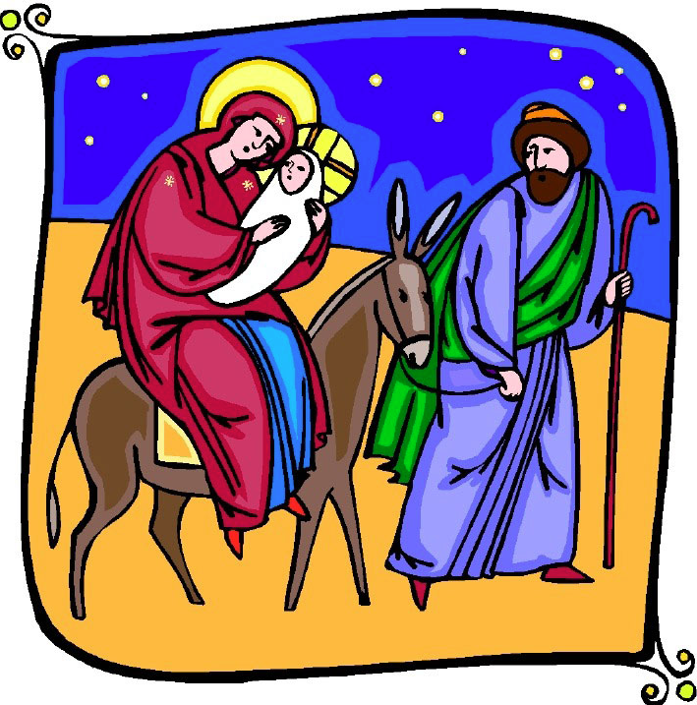
Portions of this service reprinted using CCLI Copyright License #11610749

The Nativity of Our Lord

NOTE: If it is uncomfortable for you to stand during the service, please feel free to remain seated.

MUSIC PRELUDE
WELCOME and ANNOUNCEMENTS

PROCLAMATION OF THE BIRTH OF CHRIST

GATHERING HYMN “O Come, All Ye Faithful” (vv. 1-3) ELW #283
CHRISTMAS DIALOG AND GREETING
L) The people who walked in darkness have seen a great light.
All) The light shines in the darkness, and the darkness has not overcome it.
L) Those who dwelt in the land of deep darkness, on them light has shined.
All) We have beheld Christ’s glory, glory as of the only Son from the Father.
L) For to us a child is born, to us a Son is given.
All) In him was life, and the life was the light of all people.
L) May the grace and truth of Christ be with you.
All) And also with you.

PRAYER OF THE DAY
L) Let us pray together,
All) Almighty God, You made this holy night shine with the brightness of the true Light.
Grant that here on earth we may walk in the light of Jesus’ presence and in the last
day wake to the brightness of his glory; through Your Son, Jesus Christ our Lord,
who lives and reigns with You and the Holy Spirit, one God, now and forever. Amen.

SPECIAL MUSIC: “Welcome to Our World” Arian Bunde

HYMN: “O Little Town of Bethlehem” (vv. 1-3) ELW #279

FIRST READING: Isaiah 9:2-7 Bible Pg. 555
²The people who walked in darkness have seen a great light; those who lived in a land of deep darkness— on them light has shined. ³You have multiplied the nation, you have increased its joy; they rejoice before you as with joy at the harvest, as people exult when dividing plunder. ⁴For the yoke of their burden, and the bar across their shoulders, the rod of their oppressor, you have broken as on the day of Midian. ⁵For all the boots of the tramping warriors and all the garments rolled in blood shall be burned as fuel for the fire. ⁶For a child has been born for us, a son given to us; authority rests upon his shoulders; and he is named Wonderful Counselor, Mighty God, Everlasting Father, Prince of Peace. ⁷His authority shall grow continually, and there shall be endless peace for the throne of David and his kingdom. He will establish and uphold it with justice and with righteousness from this time onward and forevermore. The zeal of the Lord of hosts will do this.
L) The Word of the Lord.
All) Thanks be to God.

HYMN: “Hark! The Herald Angels Sing” ELW #270

PSALM LITANY PSALM 96 Bible Pgs. 479-480
L) O sing to the LORD a new song; sing to the LORD, all the earth.
All) Sing to the LORD, bless his name; tell of his salvation from day to day.
L) Declare his glory among the nations, his marvelous works among all the peoples.
All) For great is the LORD, and greatly to be praised; he is to be revered above all
L) For all the gods of the peoples are idols, but the LORD made the heavens.
All) Honor and majesty are before him; strength and beauty are in his sanctuary.
L) Ascribe to the LORD, O families of the peoples, ascribe to the LORD glory and strength.
All) Ascribe to the LORD the glory due to his name; bring an offering, and come into
his courts.
L) Worship the LORD in holy splendor; tremble before him, all the earth.
All) Say among the nations, “The LORD is king! The world is firmly established; it
shall never be moved. He will judge the peoples with equity.”
L) Let the heavens be glad, and let the earth rejoice; let the sea roar, and all that fills it;
All) let the field exult, and everything in it. Then shall all the trees of the rest sing for joy
L) before the LORD; for he is coming, for he is coming to judge the earth. He will judge the world with righteousness, and the peoples with his truth.

SECOND READING: Titus 2:11-14 Bible Pg. 969
¹¹For the grace of God has appeared, bringing salvation to all, ¹²training us to renounce impiety and worldly passions, and in the present age to live lives that are self-controlled, upright, and godly, ¹³while we wait for the blessed hope and the manifestation of the glory of our great God and Savior, Jesus Christ. ¹⁴He it is who gave himself for us that he might redeem us from all iniquity and purify for himself a people of his own who are zealous for good deeds.
L) The Word of the Lord.
All) Thanks be to God.

HYMN “Away in a Manger” ELW #277

THE CHRISTMAS GOSPEL: Luke 2:1-7 Bible Pgs. 832-833
L) The Holy Gospel according to Luke, the 2nd chapter.
All) Glory to you, O Lord.
²In those days a decree went out from Emperor Augustus that all the world should be registered. ²This was the first registration and was taken while Quirinius was governor of Syria. ³All went to their own towns to be registered. ⁴Joseph also went from the town of Nazareth in Galilee to Judea, to the city of David called Bethlehem, because he was descended from the house and family of David. ⁵He went to be registered with Mary, to whom he was engaged and who was expecting a child. ⁶While they were there, the time came for her to deliver her child. ⁷And she gave birth to her firstborn son and wrapped him in bands of cloth, and laid him in a manger, because there was no place for them in the inn.
L) The Gospel of the Lord
All) Praise to you, O Christ.

SERMON Pastor Herb Wounded Head III

HYMN OF THE DAY: “Ding Dong Merrily on High” Screen

PRAYERS OF INTERCESSION “Watch, O Lord” Poinsettia insert

OFFERING: Children’s Noisy Offering for SD Kids Belong

OFFERTORY HYMN: “I Am So Glad” (vv. 1, 4-5) ELW #271

SACRAMENT OF HOLY COMMUNION

WORDS OF INSTITUTION

LORD’S PRAYER Pg. 154
L) Lord, remember us in your kingdom and teach us to pray;
All) Our Father, who art in heaven,
Hallowed by thy name,
Thy kingdom come, thy will be done,
On earth as it is in heaven.
Give us this day our daily bread,
and forgive us our trespasses,
as we forgive those who trespass against us;
and lead us not into temptation,
but deliver us from evil.
For thine is the kingdom,
and the power and the glory,
Forever and ever. AMEN.

DISTRIBUTION
Holy Communion will be served continuously in front of the chancel. God does not turn us away
from our need for grace, nor does He turn us away from the love and mercy freely given in
this simple shared meal of Jesus’ own self. All people are welcome to share in this holy meal.

THE GOSPEL of the INCARNATION John 1:1-14 Bible Pg. 862
¹In the beginning was the Word, and the Word was with God, and the Word was God. ²He was in the beginning with God. ³All things came into being through him, and all without him not one thing came into being. What has come into being ⁴in him was life, ªand the life was the light of all people. ⁵The light shines in the darkness, and the darkness did not overcome it.
⁶There was a man sent from God, whose name was John. ⁷He came as a witness to testify to the light, so that all might believe through him. ⁸He himself was not the light, but he came to testify to the light. ⁹The true light, which enlightens everyone, was coming into the world.^{b}
¹⁰He was in the world, and the world came into being through him; yet the world did not know him. ¹¹He came to what was his own, ^{c}and his own people did not accept him. ¹²But to all who received him, who believed in his name, he gave power to become children of God, ¹³who were born, not of blood or of the will of the flesh or of the will of man, but of God.
L) The Gospel of the Lord
All) Praise to you, O Christ.

Lighting of Candles
The minister lights a large candle from an altar candle, which symbolizes Christ, the Light of the world of whom John’s gospel speaks. The ushers light their candles from the minister’s candle, then light the candle of each worshipper nearest the aisle. The lighted candle is never tilted, but is always held upright when giving light to another. After all of the candles are lit, the ushers turn down the lights for the prayers.

THE PRAYERS
L) Glory to God in the highest,
All) and peace to God’s people on earth.
L) Blessed are you, Prince of Peace. You rule the earth with truth and justice.
All) Send your gift of peace to all nations of the world.
L) Blessed are you, Wonderful Counselor. You enlighten the heart with steadfast love.
All) Enliven your church that it might bear good tidings of great joy to all people.
L) Blessed are you, Emmanuel. You promise to be with us even to the end of the age.
All) Open our eyes to see your presence in all who are hungry, lonely, or homeless.
L) Blessed are you, Son of Mary. You share our humanity.
All) Have mercy on the sick, the dying, and all who suffer this day.
L) Blessed are you, Son of God. You dwell among us as the Word made flesh.
All) Reveal yourself to us in word and sacrament that we may bear your light to all the
world.

HYMN: “Silent Night! Holy Night! (v. 3 acapella) ELW #281

PRAYER
L) Let us pray.
Holy God, heaven and earth come together this holy night as we remember and celebrate the birth of your Son. In the infant Jesus you come close to us, that we might be close to you, and close to one another. Grant that the Spirit of Christ may be born anew in our hearts tonight and that we may joyfully welcome him to take charge of our lives. Open our ears to hear the angelic Gospel. Open our lips that we may join the angelic chorus, singing with uplifted hearts: “Glory to God in the highest, and on earth, peace goodwill to all.” We pray in Jesus’ name.
All) Amen.

